**Un solo hilo**

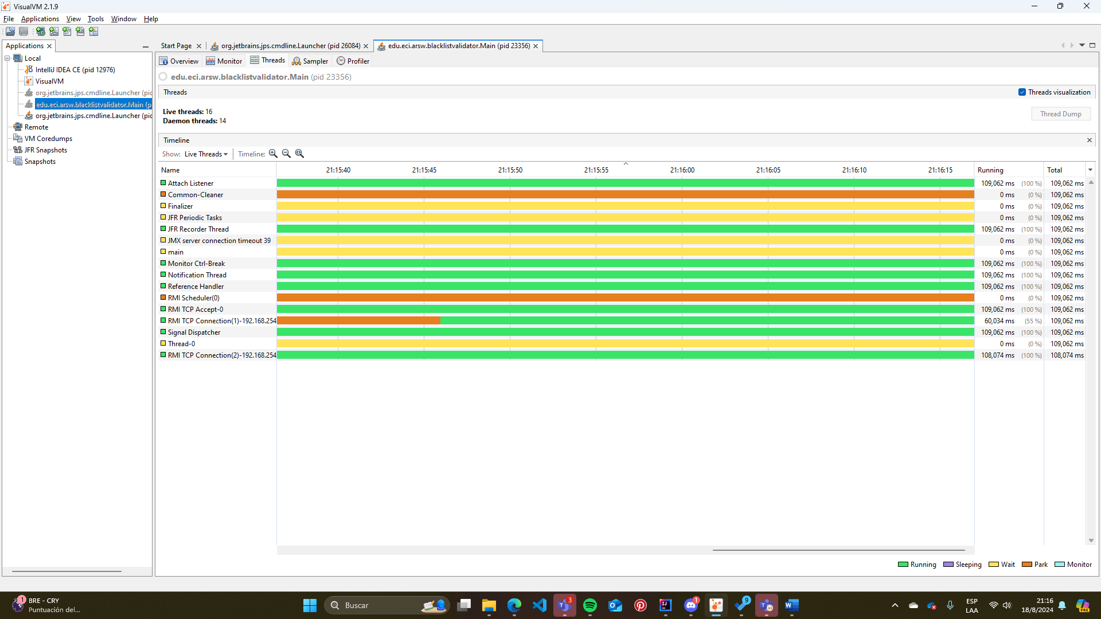

**Tiempo: 109,062 ms**

**Tantos hilos como núcleos de procesamiento (12)**

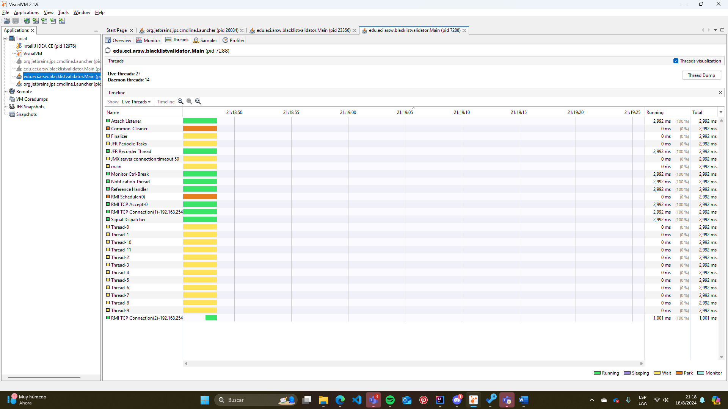

**Tiempo: 2,992 ms**

**Tantos hilos como el doble de núcleos de procesamiento (24)**

**Tiempo: 994 ms**

**5 hilos**

**Tiempo: 13,003 ms**

**10 hilos**

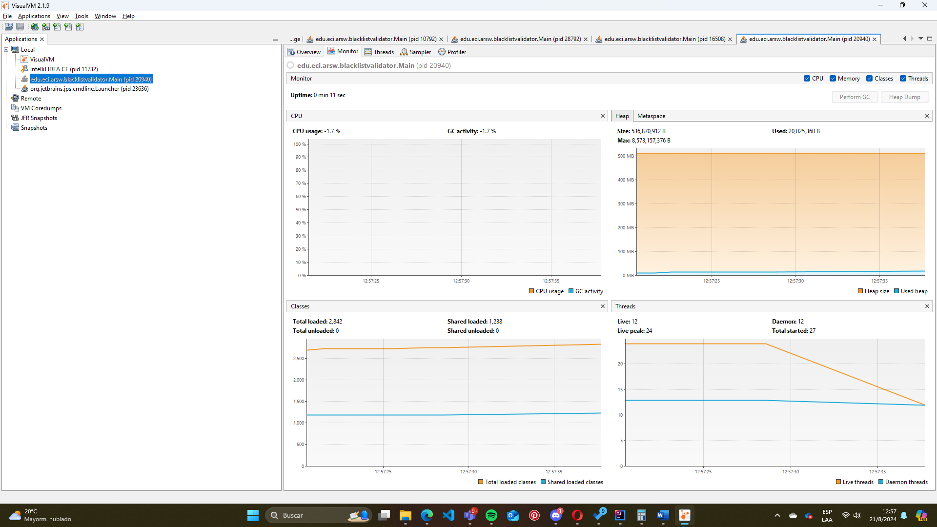

**Tiempo: 6,992 ms**

|  |  |
| --- | --- |
| Tiempo (ms) | No. Hilos |
| 109062 | 1 |
| 13003 | 5 |
| 6992 | 10 |
| 2992 | 12 |
| 994 | 24 |